**User Document For [Android] Search Results Extraction Tool**

**By Xinhao Cai**

**This document includes:**

1. **Tool function and website layout description**

**- The newest 10 threads with tag [android] from Stack Overflow**

**- The most voted 10 threads with tag [android] in the last 7 days**

**- Additional feature: most popular 5 tags extraction**

1. **Two ways to make use of this tool**

**- Run in intelliJ Idea, and deploy the website on local “tomcat 8.5.37”**

**- Run the “jar” file, and visit the generated offline website**

1. **Tool function and website layout description**

**Run the main function and the program will automatically start a connect with “stackoverflow.com”, searching for threads with [android] tag, and pull the HTML data from which it extracts the newest 10 threads and the 10 most voted threads in the last 7 days.**

* 1. **The newest 10 threads with tag [android] from Stack Overflow**

**The tool extracts the newest 10 threads and displays them on the website. Question title, question content shortcut, posted date, number of votes and answers are extracted from the original page and displayed on the newly generated website.**

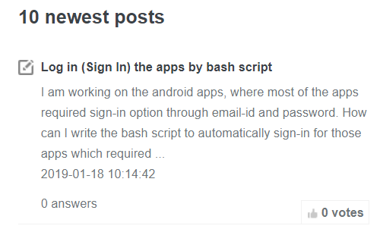

**The titles of the displayed threads are hyperlinks that redirect the users to the full question thread on Stack Overflow.**

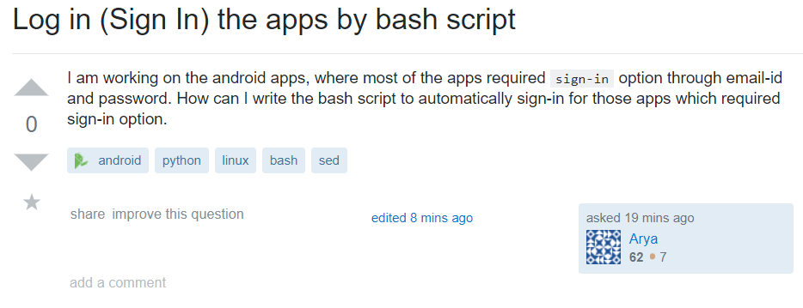

* 1. **The most voted 10 threads with tag [android] in the last 7 days**

**The tool also extracts the top voted 10 questions that are posted in the last 7 days. The same content is extracted and displayed, but the threads in this column are displayed according to the number of votes, in decreasing order.**



* 1. **Additional feature: most popular 5 tags extraction**

**Note that researchers may also be interested in the topics that are closely related to the searching term which is android in this case, the tool also finds the most frequently occurred tags: From the picture below we can find that “java”, “android-studio”, “firebase” and “kotlin”. In this case, the researchers may also need to know these frequent terms.**

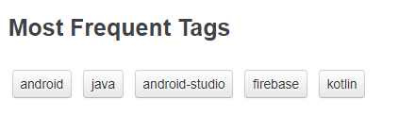

**Clicking on the tags will also redirect the users to the tags on Stack Overflow.**



1. **Two ways to make use of this tool.**
   1. **Run in intelliJ Idea, and deploy the website on local “tomcat 8.5.37”**

**This way is to run the source code in the original project made in intelliJ Idea, and this requires that the IDE intelliJ Idea is installed and “tomcat 8.5.37” is installed on local PC.**

**First we run the “Main” class to generate the required jsp page on PC, the commad line will output some intermediate string on the screen.**

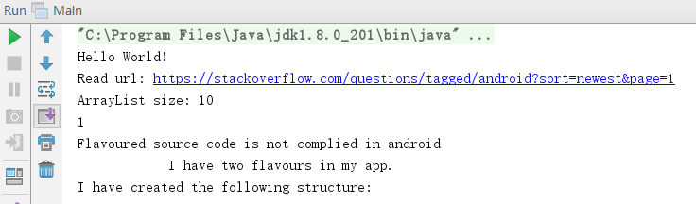

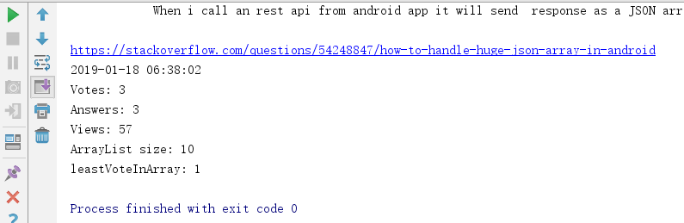

**When the “Main” class is finished, the page will have been generated and refreshed. Then we need to start the tomcat server to deploy our jsp on local server (Make sure that port 8080 is not occupied). The page will be seen on “localhost:8080/result”**

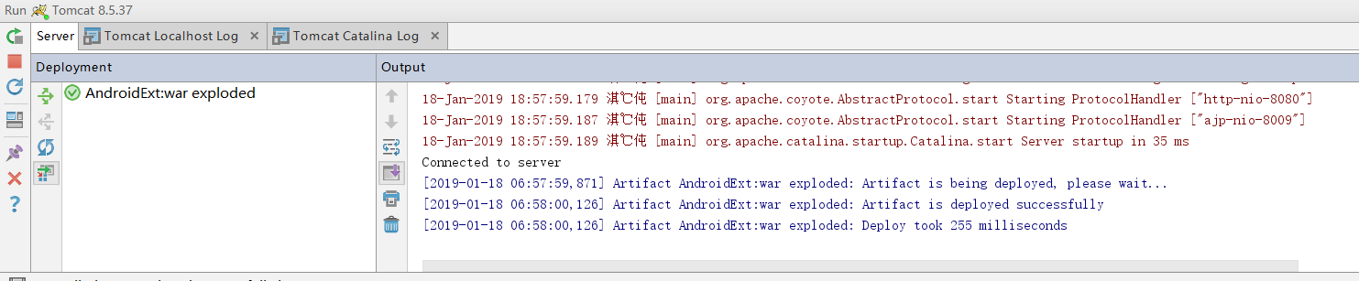

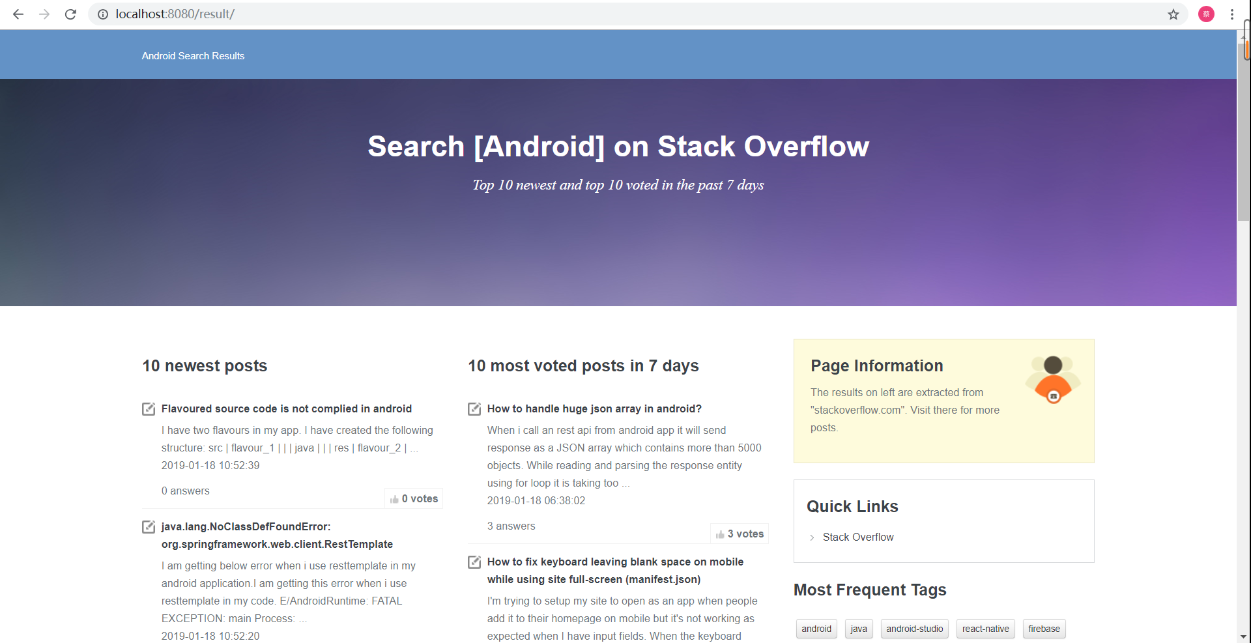

* 1. **Run the “jar” file, and visit generated offline website**

**The second way is to run the JAR file which will be included in the zipped file, then a HTML file will be generated at the folder same as the JAR file. This HTML file is the generated offline website.**



